Login Dexcom page Happy Path

TEST CASE 1 On your browser Go to https://clarity.dexcom.com/ and identify Dexcom clarity for Home users Button and press it.

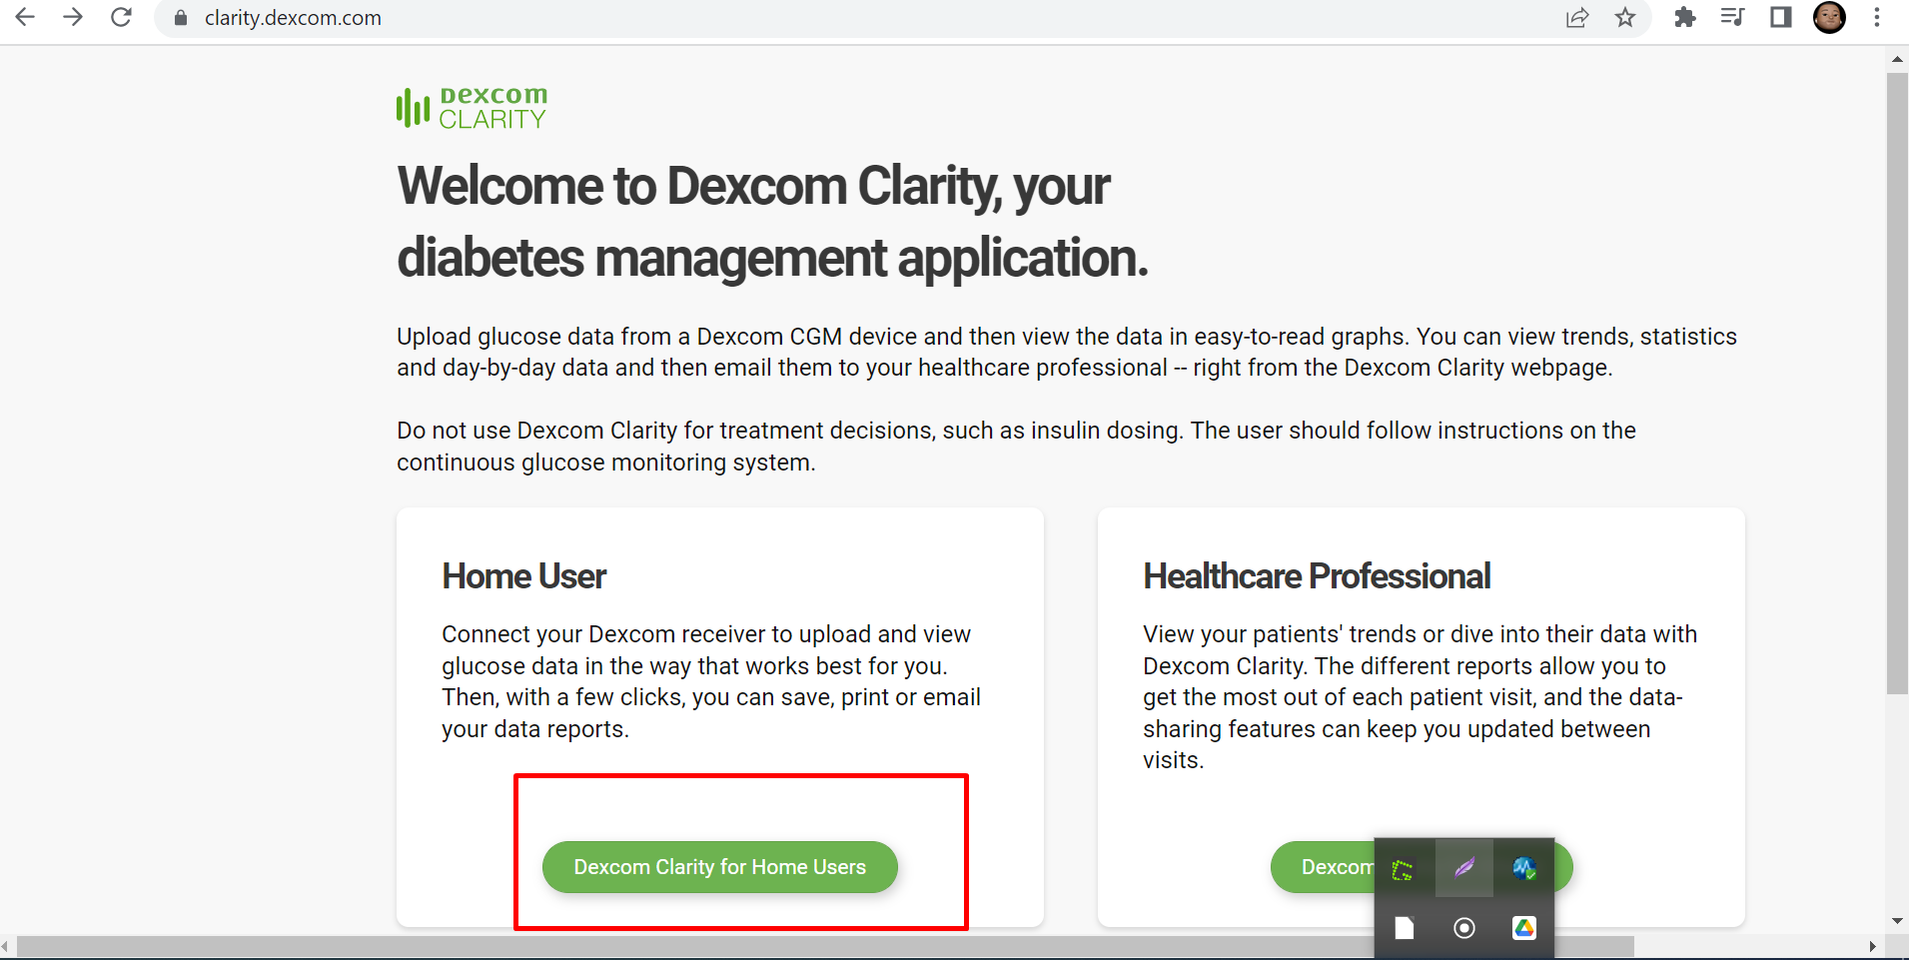

TEST CASE 2 Enter a valid username and its respective password.

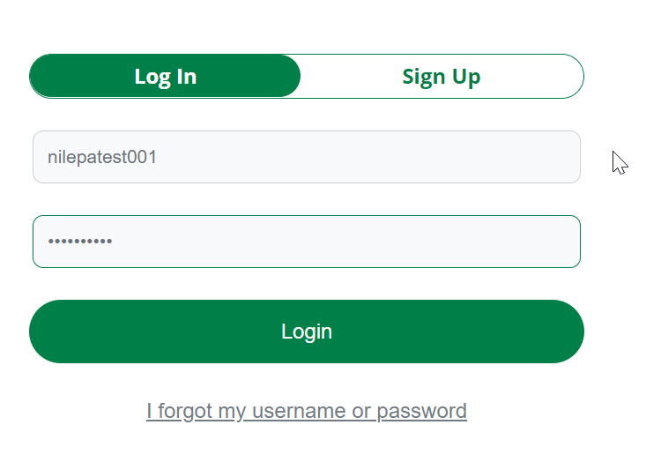

TEST CASE 3 Press the login button

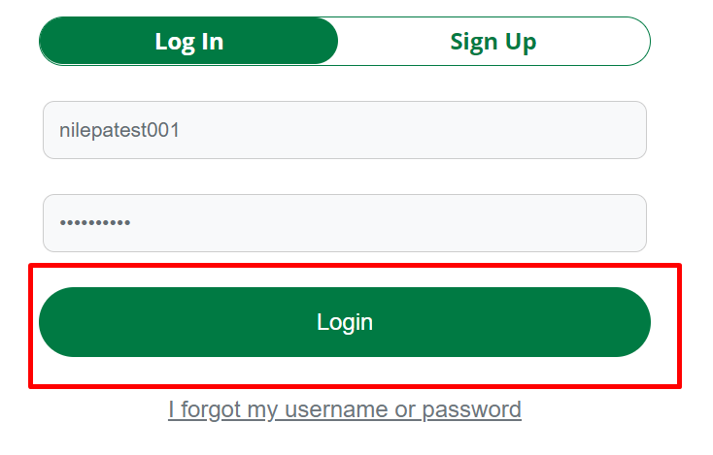

TEST CASE 4 successfully logged in

